

**NATIONAL SCHOOL OF BUSINESS MANAGEMENT**

**NSBM_UCD_19.2 / 20.1**

**Year 02 Semester 01 Examination**

**11th June 2021**

**MA 201.3 - Statistics for Computing**

**Instructions to Candidates**

**1. Answer all FOUR (4) questions.**

2. Total Number of Pages 7.

3. Time allocated for the examination is three (03) hours and 30 minutes (Including downloading and uploading time)

4. Weightage of Examination: 60% out of final grade

5. Download the paper, provide answers to the selected questions in a word document.

6. Please upload the document with answers (Answer Script) to the submission link before the submission link expires

7. Answer script should be uploaded in PDF Format

8. Please note, for the questions which require calculations, you may do it on a paper, take a photograph and attach it to the word document or do it in an excel worksheet and copy and paste it to the word document, before converting the entire document to a PDF file.

9. Under any circumstances E-mail submissions would not be taken into consideration for marking. Incomplete attempt would be counted as a MISSED ATTEMPT. 10. The Naming convention of the answer script – Module Code_Subject name_Index No 11. You must adhere to the online examination guidelines when submitting the answer script to N-Learn.

12. Your answers will be subjected to Turnitin similarity check, hence, direct copying and pasting from internet sources, friend’s answers etc. will be penalized.

Page **1** of **7**

**Question 01**

1. Simplify the following. [2 marks] a. 6P3

b. 7C4

2. James, Mary, Robert, Linda, Jessica, Thomas, and Daniel from grade 10 class are practicing a song to perform on their English day. They wanted to make their formation on the stage by standing in a line. How many ways can they stand If,

a. Mary must be in the 4th position. [2 Mark] b. James must be 2nd and Jessica must be in 3rd places? [2 Mark] c. Boys and girls alternate with a boy starting the line. [1 Mark] d. First 4 positions are for boys and last 3 positions are for girls. [1 Mark] e. They decided to keep Linda aside from the line and make the line by

other 6 students. Also, Daniel cannot be on either end of the line. How many ways can they stand? [2 Marks]

3. Answer the following questions.

a. What is meant by sample space? [1 Mark] b. As an experiment you tossed a coin 3times, find the sample space of the experiment? [2 Marks] c. In a class there are 200 students and their final grades for science are distributed as follows.

55 have got “A” grades, 60 have got “B” grades, 75 have got “C” grades, 10 have got “D” grades.

If a student from this group selected at random what is the probability that this student has got a “D” grade? [2 Marks]

4. The below table shows the distribution of votes in 5 Districts in the 2020 Election.

| **District** | **Mr. X** | **Mr. Y** |
| --- | --- | --- |
| Colombo | 581 | 472 |
| Gampaha | 345 | 336 |
| Kalutara | 349 | 207 |
| Galle | 260 | 210 |
| Matara | 148 | 197 |

a. Probability that a voter from Kalutara district, voted for Mr. X? [2 Marks] b. Probability that a voter is from Colombo district? [2 Marks] c. Probability that a voter is form Galle or voted for Mr. X? [2 Marks]

Page **2** of **7**

5. A box contains 5 red and 2 blue balls. A ball is drawn at random, and it is not replaced. Then a second ball is drawn at random.

a. Using a tree diagram show all the possible outcomes? [2 Marks] b. Find the probability of getting at least one blue ball. [1 Mark] c. Find the probability of getting tow of same colour. [1 Mark]

**[Total = 25 marks]**

**Question 02**

1. A sociologist is investigating the changing pattern of the number of children which women have in a country. She donates the present number by the random variable x which she finds to have the following probability distribution.

Find the value of a. [03 marks]

| r | 0 | 1 | 2 | 3 | 4 | 5+ |
| --- | --- | --- | --- | --- | --- | --- |
| P(X=r) | 0.09 | 0.22 | a | 0.19 | 0.08 | negligible |

2. A general knowledge quiz hasten questions. Each question hasthree possible answers of which only one is correct. A woman attempts the quiz by pure guesswork. a. What is the probability that she obtains exactly 2 correct answers? [02 marks]

b. What is the probability that she obtains not more than 2 correct answers? [03 marks]

3. The number of incoming telephone calls received per minute by a company’s telephone exchange follows a Poisson distribution with mean 1.92. find the probabilities of the following events.

a. Exactly two calls are received in a one-minute interval. [03 marks] b. Exactly two calls are received each minute in a five-minute interval. [04 marks]

4. The weekly wages of 1000 workmen are normally distributed around a mean of Rs. 70/- and with standard deviation of Rs. 5/-. Estimate the number of workers whose weekly wages will be,

a. Between Rs. 69 and 72. [02 marks] b. Less than Rs. 63. [03 marks] c. More than Rs. 80. [03 marks] d. Between Rs. 70 and 72. [02 marks]

**[Total = 25 marks]**

Page **3** of **7**

**Question 03**

The following table shows the number of motor registrations in a certain territory for a term of 5 years and the sale of motor tyres by a firm in that territory for the same period.

| **Year** | **Motor Registrations** | **No of Tyres sold** |
| --- | --- | --- |
| 1 | 600 | 1250 |
| 2 | 630 | 1100 |
| 3 | 720 | 1300 |
| 4 | 750 | 1350 |
| 5 | 800 | 1500 |

a. Define the independent and dependent variables in the scenario. [02 marks]

b. Develop a suitable graph for the above details and interpret the relationship. [05 marks]

c. Develop the regression equation and estimate the sale of tyres when registration is 850. [12 marks]

d. Calculate the correlation coefficient and interpret. [04 marks] e. State the underlying concept and assumptions made. [02 marks] **[Total = 25 marks]**

**Question 04**

1. Observations over a long period of time have shown that the mass of adult males of a type of bat has an average weight of 110g. A scientist has a theory that in one area these bats are becoming smaller. Possibly as an adaption to changes in their environment. He plans to trap 20 adult male bats, weigh them, and then release them. He will then use the data to carry out suitable hypothesis test at the 5% significant level.

a. State the null and alternative hypotheses. [04 marks] b. If the mean mass of the scientist’s sample of bats is 107g with the standard deviation being 10, compute the value of the test statistic. [04 marks]

Page **4** of **7**

2. It is known that the mass of a certain type of lizard has a normal distribution with mean 72.7g and standard deviation of 4.8g. a zoologist finds a colony of lizards in a remote place and is not sure whether they are of the same type. In order to test this, she collects a sample of 12 lizards and weighs them, with ��̅being 75.25g.

a. Write down in precise form the zoologist’s null and alternative hypotheses, and state whether a one-tail or two-tail test is appropriate. [05 marks] b. Carry out the test at the 5% significant level and write down your conclusions. [08 marks]

c. Would your conclusion have been the same at the 10% significant level? [04 marks]

**[Total = 25 marks]**

-----End of the Paper-----

Page **5** of **7**

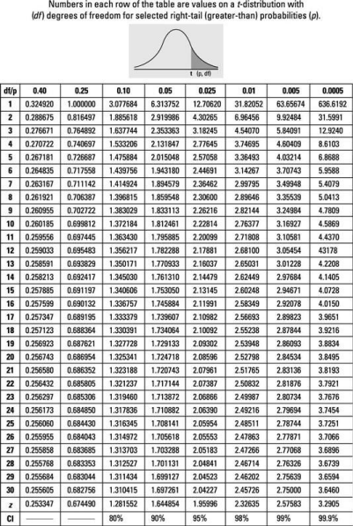Page **6** of **7**

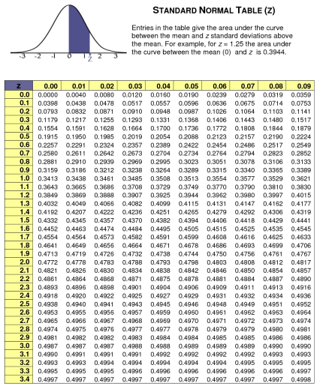Page **7** of **7**